World Menopause Day – the School Edition!
What do we mean by menopause and perimenopause?
Menopause happens when we stop menstruating. Because we don’t know we’ve stopped our periods until we they don’t come back, we count it as a year after our last period. By that time our bodies are making very little oestrogen or progesterone, and the levels are constant. If you bleed after this point you should see a doctor, just in case.
Perimenopause is the period before menopause when our hormones are fluctuating. For many of us this is the most challenging part and it tends to happen in our late thirties or early forties when we’re busiest with our careers and our families. Sometimes this only lasts a couple of years – for others it last for more than ten. Hanging on in there may not be a great option!
Post-menopause is after we have passed the point of menopause. We will be postmenopausal for the rest of our lives.
Some of us have a much earlier menopause for natural or medical reasons.
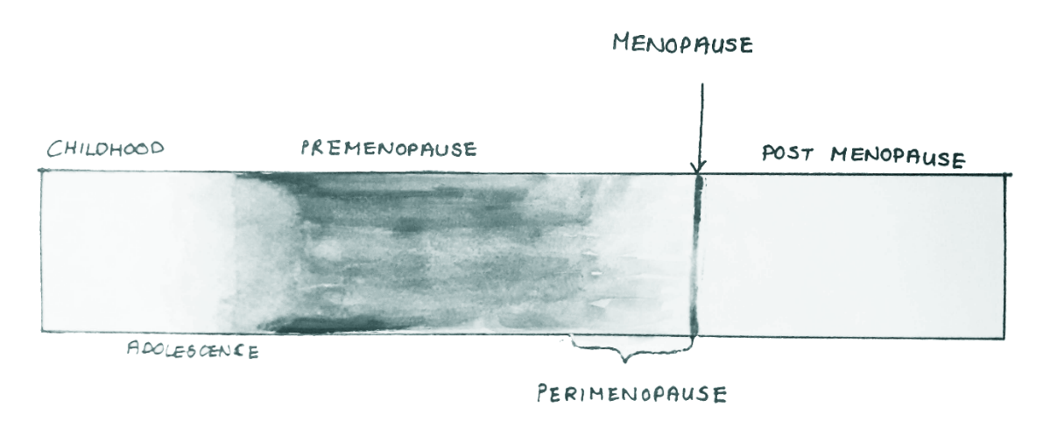
What Problems Does It Cause?
It varies. About 1 in 5 of us get through with no difficulty. Another one in five have a nightmare of a time, and most of us fall somewhere in the middle.
Most people are aware of hot flushes – although not necessarily how distressing and disruptive they can be. We know our periods will change – although we might not be prepared for them to get longer, heavier and closer together before they start to dwindle. We might also notice difficulties with our genito-urinary systems and a number of other physical discomforts. This is a good list of some of the symptoms that might be experienced – but it’s important to say that we don’t all get all of them.
But perimenopause happens as much in the brain as the body (which does not mean it’s all in the mind). Oestrogen helps our brain cells metabolise – burning sugar to get energy – and that slows down as we go through perimenopause. The body pumps extra blood to the brain to compensate but it can still be tough.
We often worry most about brain fog, which is a catch all term for fatigue, loss of memory – especially verbal memory – and difficulty in making decisions. Poor sleep can play a role here. The amygdala which is in charge of our primary emotional responses is also affected – and this can cause anxiety, depression, irritability or even rage.
Many of these symptoms settle down as we pass into post-menopause.
Why does this matter in schools?
Firstly it’s a job we do with our brains! We need to remember everything from children’s names to where we keep the glue to (for me at least!) the Krebs cycle. Mostly we need to remember what we were going to say next.
When that happens it not only slows us down, it’s embarrassing and can be a real knock to our self-confidence.
In our work we manage children and young people who are not yet good at managing their emotions – which means we have to be extra good at managing ours. Working in schools can become really hard if we’re struggling with that.
The school environment is a restricted one. At any given time we’re supposed to be in a certain place, with certain people doing a certain thing. There’s not much room to flex around our needs.
That’s a big deal when it comes to something as simple as using the toilet. Educators often have exceptional bladder control – but that can get tricky as our oestrogen levels drop and the bladder tissue gets less strong and stretchy. In addition there’s the worry about unpredictable bleeding and staining. Getting to the loo can also be a concern for men with prostate issues.
Temperature matters too – particularly if you’re in a science lab (as I was) with blackout blinds and twenty Bunsen burners on full blast. The same is also true where you’ve got ovens going, or classrooms with lots of windows or you’re trying to keep small people nice and warm.

How Can We Help Ourselves?
There is a whole range of hormonal and non-hormonal medical options that can help. The best source of information around this is the British Menopause Society. Be aware that responses to treatments are individual and finding the right solution might take time – and might also change over time. Hang on in there!
Lifestyle adjustments help too – from Sleep Hygiene to exercise and meditation. Exercise is particularly useful for our bones when it’s weightbearing, but it also helps us manage hot flushes while other kinds of exercise help with flexibility or our pelvic floor. We’re probably also going to want to keep a lid on our carbohydrate intake and make sure we get plenty of protein and fibre and fruit and vegetables – but there’s rarely a need for anything more complicated than that. We have enough going on without being afraid of our food.
It's also really important to manage our stress levels. All the problems our brain is having – with brain fog, with memory and with mood – get worse when we’re stressed. Working in schools is stressful and these are very stressful times, even before we start dealing with menopause.
One of the ways to help manage our stress is to make sure the life we lead outside of school is fulfilling. It’s easy to stop doing the things we love because we’re tired and fear overwhelm, but when we lose our joy we are more prone to stress.
It’s also important to ask other people in our lives to support us. We don’t always have to be brave!
This is a really good time in our lives to build healthy habits that will carry us forward as we age. This means we have to prioritise our own health, which can come as a bit of a surprise to other people. Fortunately we tend to become more assertive around menopause too…
Top Tips For Dealing with Menopause in Schools
- Wearing loose, light, layered clothes in natural fabrics helps manage your temperature. Bring a hanger to work for the clothes you take off!
- Have a fan. Have many fans. Have beautiful fans – in my experience the old-fashioned sort work better than the battery ones.
- Keep water to hand. See if you can find a way of keeping it chilled.
- If you’re struggling with bleeding you may need to see if there’s a safe accessible place to keep a change of clothing – perhaps in the toilet.
- Create a comfort pack for yourself with a supply of sanitary protection, water, painkillers, fan, cooling wipes, healthy snacks and anything else that helps.
- Try and plan in ‘brain breaks’. The temptation is often to work through breaks and finish earlier, particularly when you have a lot to do, but the brain responds to a change of pace and a change of scene. Just a few minutes walking in fresh air – or simply looking at something different – can perk you up.
- The more you can keep calm the better your brain will function. Deep breathing using your belly activates the parasympathetic nervous system which calms your whole body.
- Cooling your face will do much the same – either by splashing on water or using a damp cooled cloth. You can get neck chillers which are very useful – here’s how you make one. This helps keep you calm as well as managing hot flushes.
- If anxiety is getting to you, ground yourself in the moment by listing what you can see, hear and touch. Wear your favourite perfume and add smell!
- Practice saying ‘no’…
How do we help our colleagues?
- By letting them talk about menopause when they want to, and taking it in your stride – but understanding that they might prefer not to.
- By listening.
- By not making assumptions.
- By asking them what they need.
- By switching duties or keeping an eye on someone’s class if asked.
- By understanding that your colleague’s competence is not affected just because their memory fails them from time to time.
- By respecting their occasional need for a moment of ‘me time’.
- By accepting that creating a culture which values people’s well-being benefits us all.
What you can ask of your school?
- Ask if they’ve got a menopause policy.
- Know who to talk to about menopause before you need to.
- Discuss their policy around absence. Deferring medical appointment until school holidays will only delay finding solutions.
- Talk to them about the organisation of the school day if that’s contributing to difficulties around visiting the toilet or keeping your brain sharp.
- Ask if they can provide a fan in the classroom.
- Is there a possibility of moving classrooms so you have better access to toilets or fresh air?
- Can they provide lockers in toilets and a safe place for your handbag?
- See if they will allow you off site during non-contact time so that you can perk up your brain.
- Ask for a secure, convenient place to keep your handbag or bag of supplies.
- Can they provide a coat hook in your classroom or a safe place to keep all your discarded layers of clothes?
- Ask if there’s someone you can email if you need emergency cover to nip to the loo.
Asking doesn’t, of course, mean that you’ll get – schools are complex institutions and school leaders are balancing many competing demands. But it’s worth communicating your needs clearly and asking what they are able to offer to help.
Find out more about how schools can deal with menopause here.

Happy World Menopause Day!
For more help and information you can find me on Twitter as @haclare or check out the links at linktr.ee/Helenclare
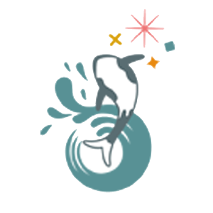

Helen Clare
MENOPAUSE IN SCHOOLS

