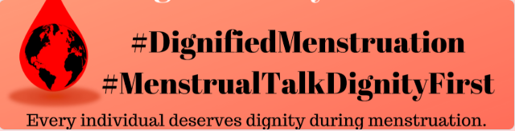

The International Workshop on Dignified Menstruation
May 26th - 28th 2020, Kathmandu, Nepal
https://www.dignifiedmenstruation.org/
Deadline for Application: January 31, 2020
The accommodation: International participants will be accommodated in double bedrooms (two participants in one room). If you need a single bed and room, please book in advance. We will assist you to find cheap hotels nearby venue if you need.
The refreshments and lunch will be served at the conference.
Registration fee:
$150 for Nepali Individuals/students
$400 for organizations and citizen from aboard
GSCDM will have little financial support for individuals in need; financial support applications will be announced soon.
You can use any mode for fees:
1. Paypal: Dignified Menstruation Paypal Link
2. Bank account:
Bank Name: Nabil Bank Ltd.,
Bank Address : Teendhara Branch, Kathmandu, Nepal
Account Name: Radha Paudel Foundation
Account Number: 01701017501816
Swift Code: NARBNPKA
* Required

Email address: *
Name: *
Date of Birth: *
Citizenship: *
Passport and Expiry date for Passport: *
Gender:
Email Personal and/or Email Official: *
Phone Personal and/or Phone- Official/ org Website:
WhatsApp/Skype ID:
Mailing Address:
Highest Education (we do not require any academic degrees for participation; though appreciate if you mention the educational status):
Option 1
Organization name if you have any: Position: Duration
What are your experiences relating to menstruation, gender equity, or relating topics for last five years?(100 words): *
Why do you want to participate in this conference? Chose any of the options and explain in 300 words Exposure to the topic; Contribution as a speaker; Contribution as a thematic expert; others (explain) *
What are some specific works you have done in the local, national, and/or regional level in your country relating to Dignified Menstruation? 300 words *
What are some issues related to dignified menstruation in your country and region? 300 words *
What are some main policy gaps in your country for dignified menstruation? 300 words *
Give two examples of how an individual’s dignity is compromised during menstruation. 300 words *
How would you contribute to the conference at a personal and organizational level? 200 words *
What are some things you could change/do to eliminate menstruation discrimination and establish dignified menstruation in your country/region in the next two years? *
What are some things you could change/do to eliminate menstruation discrimination and establish dignified menstruation in Asia in the next two years? *
What does dignity with menstruation look like to you? 200 words. *

Please address the application form to: DignifiedMenstruation2019@gmail.com

